Practical Implementation of Decision Tree using R Tool
Install party package and select cran mirror as Canada(NS) from others
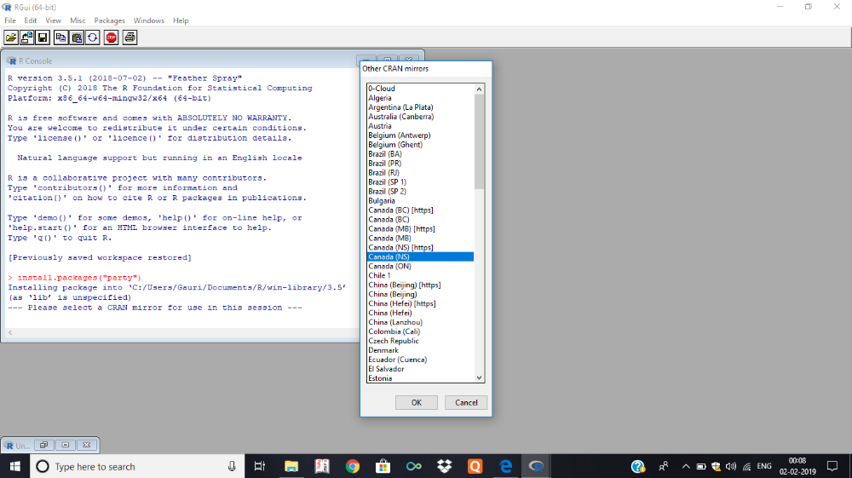

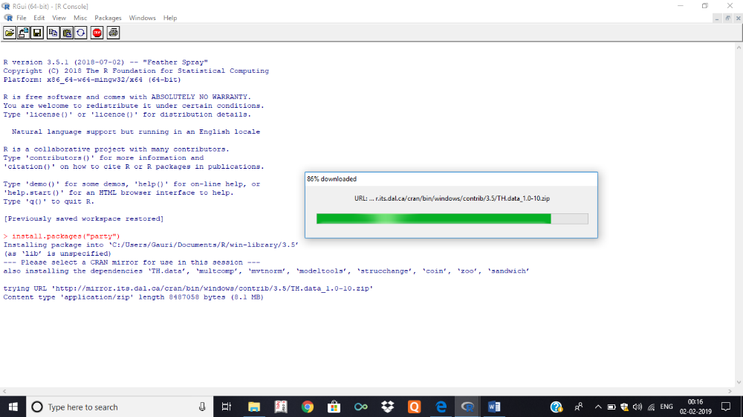

All packages will be downloaded and installed
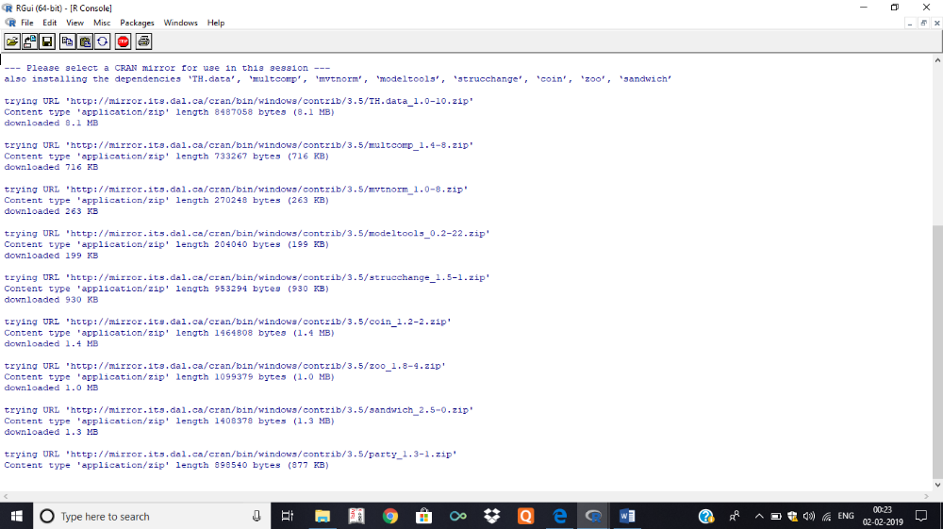

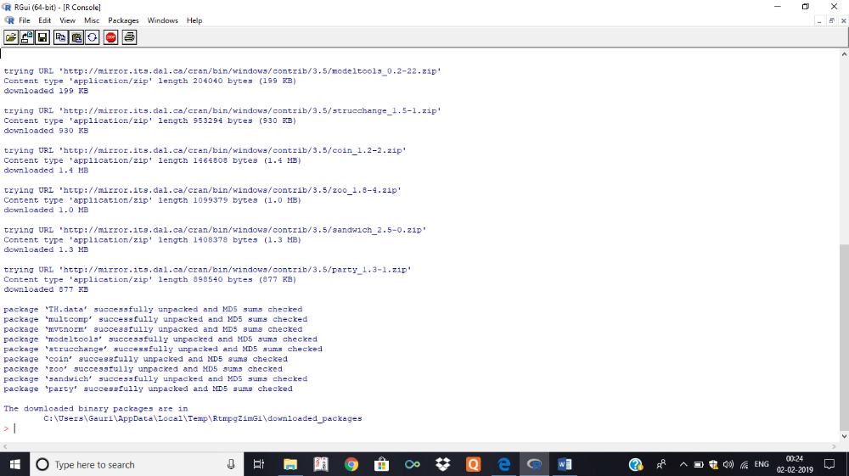

Above screenshots shows installation of packages.
The package "party" has the function ctree() which is used to create and analyze decison tree.
Syntax
The basic syntax for creating a decision tree in R is −
ctree(formula, data)
Input Data
We will use the R in-built data set named readingSkills to create a decision tree. It describes the score of someone's readingSkills if we know the
variables "age","shoesize","score" and whether the person is a native speaker or not.
Here is the sample data.
# Load the party package. It will automatically load other
# dependent packages.
library(party)

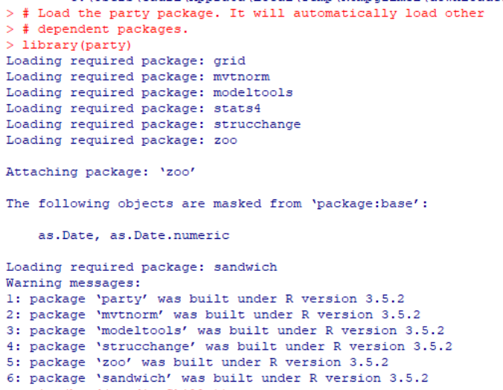
# Print some records from data set readingSkills.
print(head(readingSkills))

# Create the input data frame. input.dat <- readingSkills[c(1:105),]
# Create the input data frame
input.dat <- readingSkills[c(1:105),]
# Give the chart file a name.
png(file = "decision_tree.png")

# Create the tree.
output.tree <- ctree( nativeSpeaker ~ age + shoeSize + score, data = input.dat)
# Plot the tree.
plot(output.tree)
# Save the file.
dev.off()
# Plot the tree.
plot(output.tree)

SEM II 2024 REGULAR NEP

